Project Design Phase-II
Data Flow Diagram & User Stories

Date | 15 Feb 2026
Team ID | LTVIP2026TMIDS88736
Project Name | Exploratory Analysis of Rainfall Data in India for Agriculture
Maximum Marks | 4 Marks

Data Flow Diagrams:
A Data Flow Diagram (DFD) is a graphical representation that illustrates how data moves within a system. It clearly shows how data enters the system, how it is processed or transformed, where it is stored, and how it exits the system. A well-designed DFD presents system requirements in a simple and structured visual format, making it easier to understand the overall flow of information.
Example: DFD Level 0 (Industry Standard)
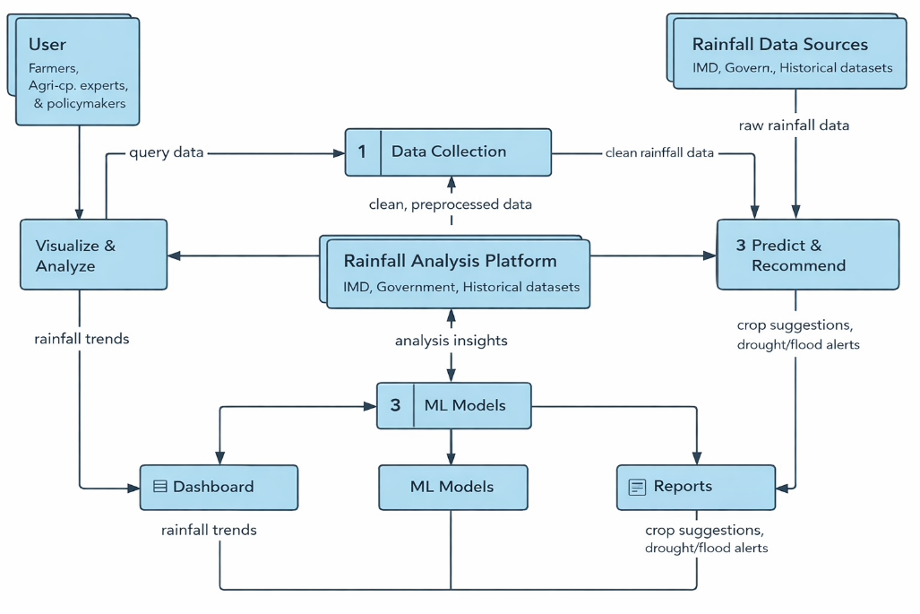
Example: (Simplified)
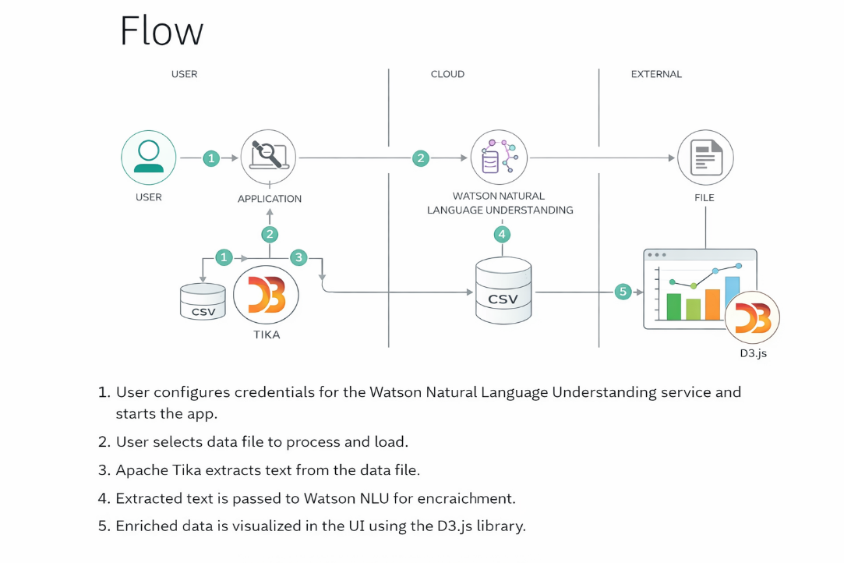

User Stories
Use the below template to list all the user stories for the product.
User Type | Functional Requirement (Epic) | User Story Number | User Story / Task | Acceptance Criteria | Priority | Release
Farmer / Research User | Registration | USN-1 | As a user, I can register using email and password to access rainfall insights | User account created and dashboard accessible | High | Sprint-1
Farmer / Research User | Confirmation | USN-2 | As a user, I receive confirmation after registration | Confirmation message/email received | High | Sprint-1
Farmer / Research User | Login | USN-3 | As a user, I can login to access rainfall dashboard | Successful login and access granted | High | Sprint-1
Farmer / Research User | Dashboard | USN-4 | As a user, I can view rainfall visualizations and charts | Charts load without error | High | Sprint-1
Farmer / Research User | Data Upload | USN-5 | As a user, I upload rainfall dataset for analysis | Dataset uploaded and processed | High | Sprint-1
Farmer / Research User | Trend Analysis | USN-6 | As a user, I analyze rainfall patterns and trends | Insights displayed correctly | High | Sprint-1
Farmer / Research User | Report Export | USN-7 | As a user, I download analysis report | Report downloaded successfully | Medium | Sprint-2
Admin | Dataset Management | USN-8 | Admin uploads datasets for system training | Dataset stored and usable | High | Sprint-1
Admin | Model Training | USN-9 | Admin trains ML models on rainfall data | Model training completes | High | Sprint-1
Admin | User Management | USN-10 | Admin manages user accounts | Users added/removed/edited | Medium | Sprint-2
Policy Analyst | Risk Insights | USN-11 | Analyst views rainfall risk insights | Insights visible and accurate | Medium | Sprint-2

